Router – Standard ACL List Commands
Allow:
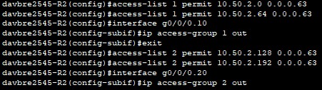
Deny:
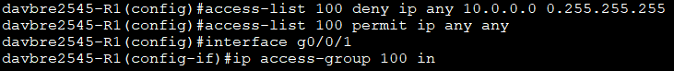

Router – Extended ACL List Commands
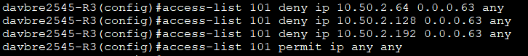
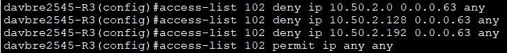
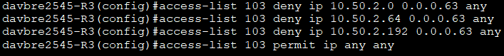
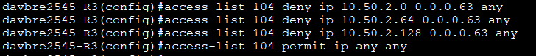
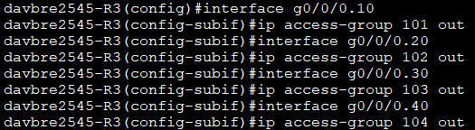

Router – BGP
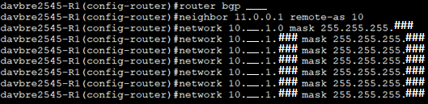

Router – IPv6 ACL
